**NANDHA ENGINEERING COLLEGE**

**(AutonomousInstitution)**

Erode-638 052



**TABLEAU-TWO CREDIT COURSE**

**IV–Semester**

**B.Tech - Artificial Intelligence and DataScience**

**NAME : B S KAVYA SREE**

**BRANCH : B.TECH AI & DS**

**YEAR : II**

**TABLEAU**

Tableau is a powerful data visualization software that allows users to create interactive and shareable dashboards. It helps in transforming raw data into visually appealing, easy-to-understand graphs, charts, and reports. With its user-friendly interface, Tableau enables individuals to connect to various data sources, perform complex data analysis, and visualize trends and patterns without requiring advanced programming knowledge. The software is widely used in fields such as business intelligence, data analysis, and reporting, making it an essential tool for data-driven decision-making. Tableau supports real-time data updates, and its ability to handle large datasets efficiently makes it ideal for organizations seeking to gain actionable insights from their data.

**PROJECT TITLE:**

**“CREDIT SCORE CLASSIFICATION”**

* Credit Score Classification groups individuals based on their creditworthiness.
* It helps banks and companies decide whether to approve loans or offer financial products.
* Customers are usually classified into categories like Good, Average, and Poor credit scores.
* A good credit score means low debt, timely payments, and responsible credit usage.
* An average credit score indicates moderate debt levels and occasional missed payments.
* A poor credit score suggests high debt, frequent late payments, and high credit utilization.
* Important factors include payment history, outstanding debt, credit utilization ratio, and credit history length.
* Classification allows faster and safer financial decisions for lenders and businesses.
* Credit score classification can be done using manual rules or predictive machine learning models.
* Data visualization tools like Tableau make it easy to understand and present credit classification results.

**1.NUMBER OF LOANS PROVIDED BASED ON OCCUPATION**

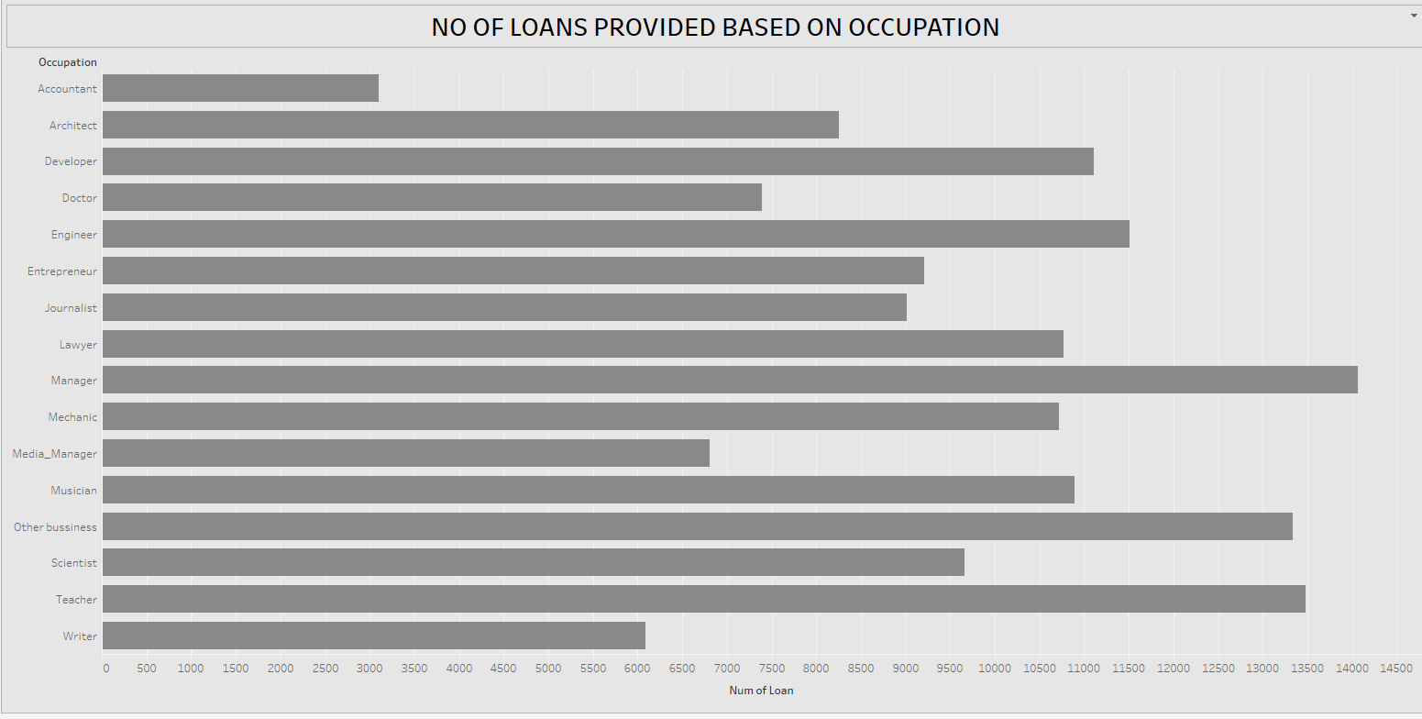

• The chart shows the total number of loans given across different occupations.

•**Managers** received the highest number of loans.

•**Engineers**, **Teachers**, **Developers**, and **Other Business** occupations also received a large number of loans.

•**Doctors**, **Mechanics**, **Scientists**, and **Media Managers** received comparatively fewer loans.

•**Accountants** and **Scientists** are among the occupations with the lowest number of loans.

• The distribution suggests that people in leadership, business, and technical roles have greater access to loans.

**2.CREDIT LIMIT BASED ON PAYMENT BEHAVIOUR**

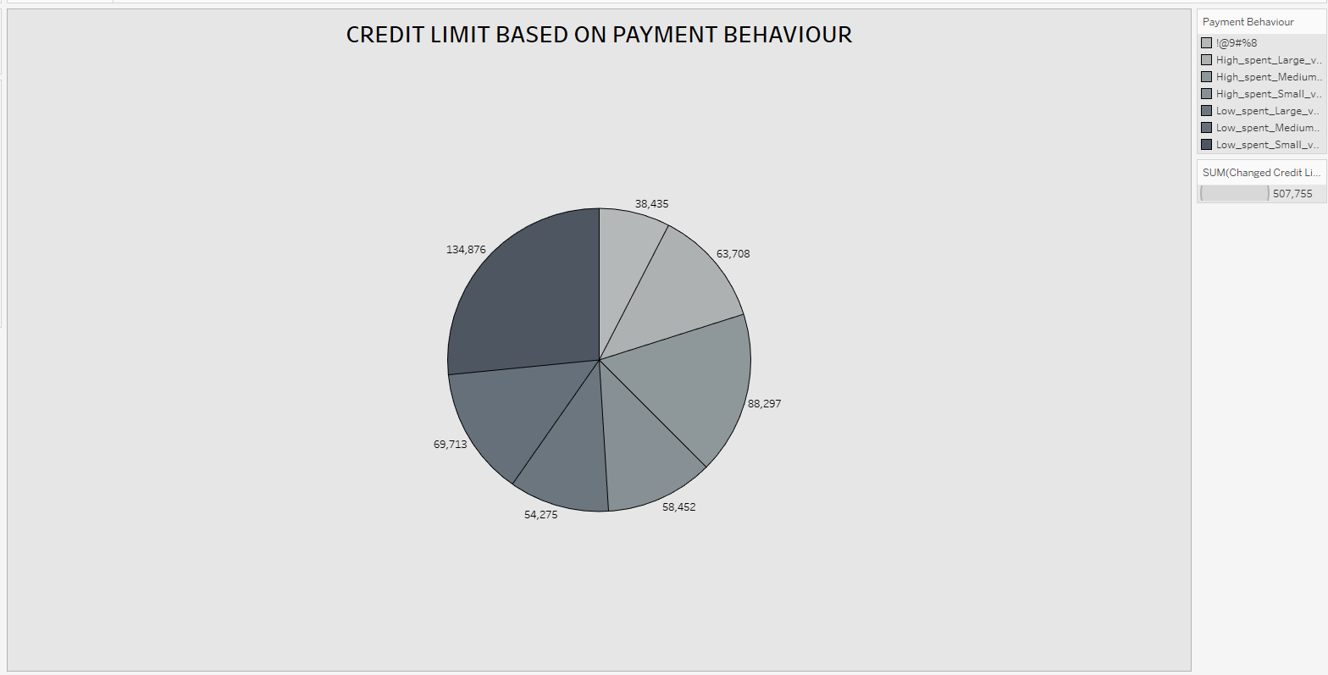

* Customers are classified based on their spending amount (High spent or Low spent) and transaction volume (Large, Medium, Small).
* Each group’s total credit limit is calculated by summing up the credit limits of all customers in that group.
* The largest slice in the pie chart (134,876) most likely represents customers with High spending and Large transaction volumes, meaning they spend more and more frequently, hence have higher credit limits.
* Smaller slices like 38,435 represent customers with Low spending and Small transaction volumes, meaning they spend less and less frequently, thus assigned lower credit limits.
* The total credit limit considered in the chart is 507,755, divided among all classified payment behavior groups.

**3.MONTHLY INHAND SALARYVS MONTHLY BALANCE**

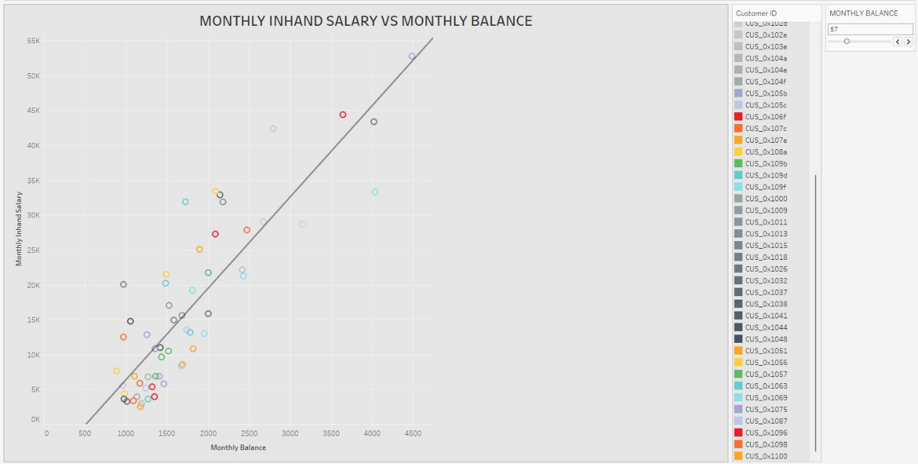

* This scatter plot visualizes the relationship between customers' Monthly Inhand Salary (y-axis) and their Monthly Balance (x-axis). Each point represents an individual customer, uniquely colored based on their Customer ID.
* The chart includes a trend line, which shows the general direction and strength of the relationship between the two variables. The trend line is upward-sloping, indicating a positive correlation: generally, as a customer's monthly inhand salary increases, their monthly balance also tends to increase.
* However, the spread of points around the trend line suggests some variability — not every customer with a higher salary maintains a proportionally higher balance, implying differences in spending or saving habits among customers.
* Most customers have a Monthly Balance between 500 and 3000.
* A few outliers with high salaries (~50K) exist, but their balances vary.
* Customers with lower salaries often have lower balances, but with significant variation.

**4. MONTHLY BALANCE BASED ON OCCUPATION**

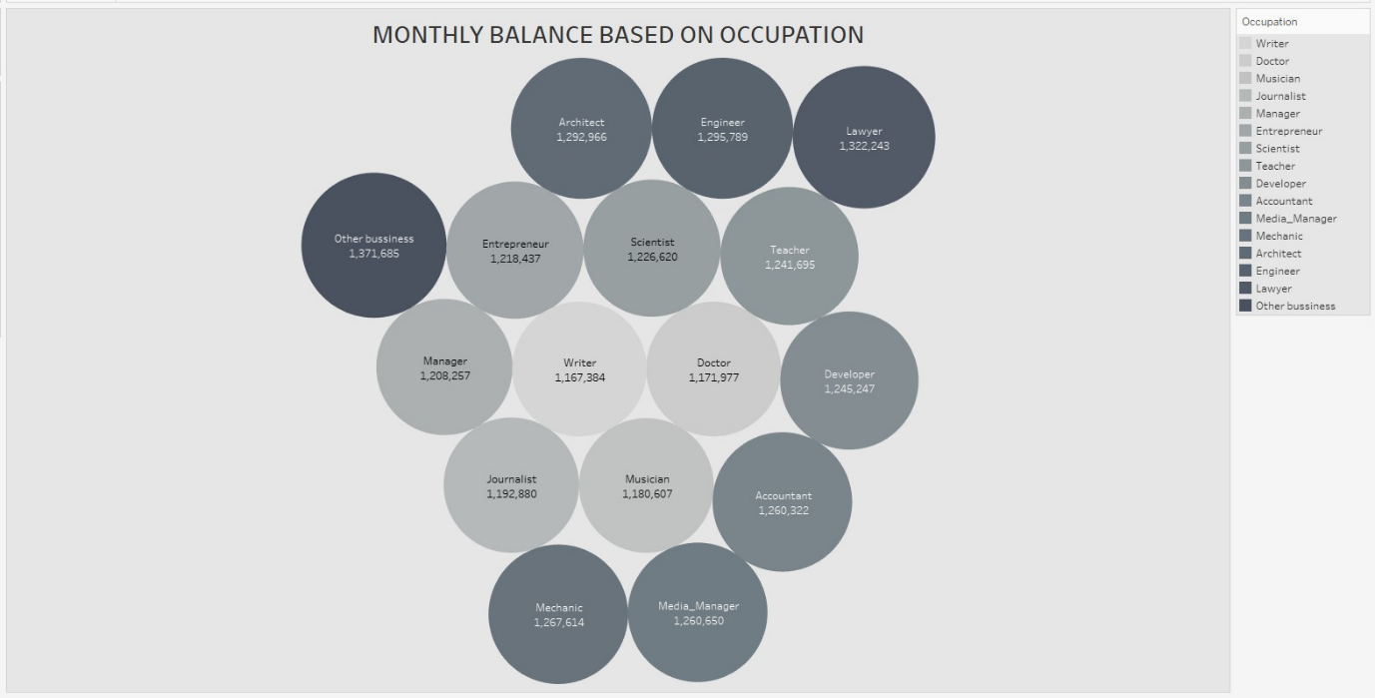

* Each bubble corresponds to a different occupation and shows the average monthly balance associated with it. The size of each bubble roughly reflects the balance amount — larger bubbles represent higher balances.
* The occupations included range across multiple fields like Engineer, Lawyer, Scientist, Doctor, Writer, Journalist, Entrepreneur, Developer, Architect, Musician, Mechanic, Media Manager, Accountant, Manager, Teacher, and Other business.
* Each occupation is also color-coded in various shades of gray, with a legend on the right side helping to identify them.
* Other business has the highest monthly balance of 1,371,685.
* Engineer (1,295,789) and Architect (1,292,966) also show very high balances.
* Lawyers earn a significant balance too, at 1,322,243.
* Writer (1,167,384) and Musician (1,180,607) have lower monthly balances compared to others.

**5.INTEREST RATEOF CUSTOMERS**

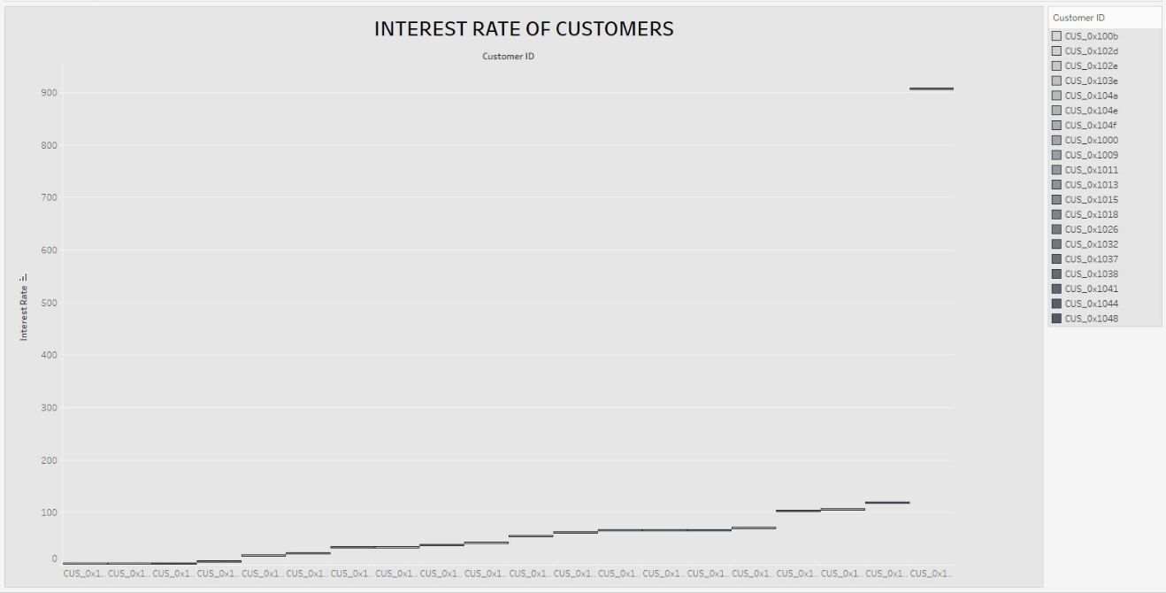

* The x-axis represents Customer IDs.
* The y-axis represents the Interest Rate.
* Most customers have low to moderate interest rates.
* There is a gradual increase in interest rates among customers.
* A few customers show abnormally high interest rates, crossing 900.
* One customer in particular is a major outlier with an exceptionally high rate.
* A legend on the right lists the Customer IDs with different shades to differentiate them.

**6. NUMBEROFLOANSTAKEN PERMONTH**

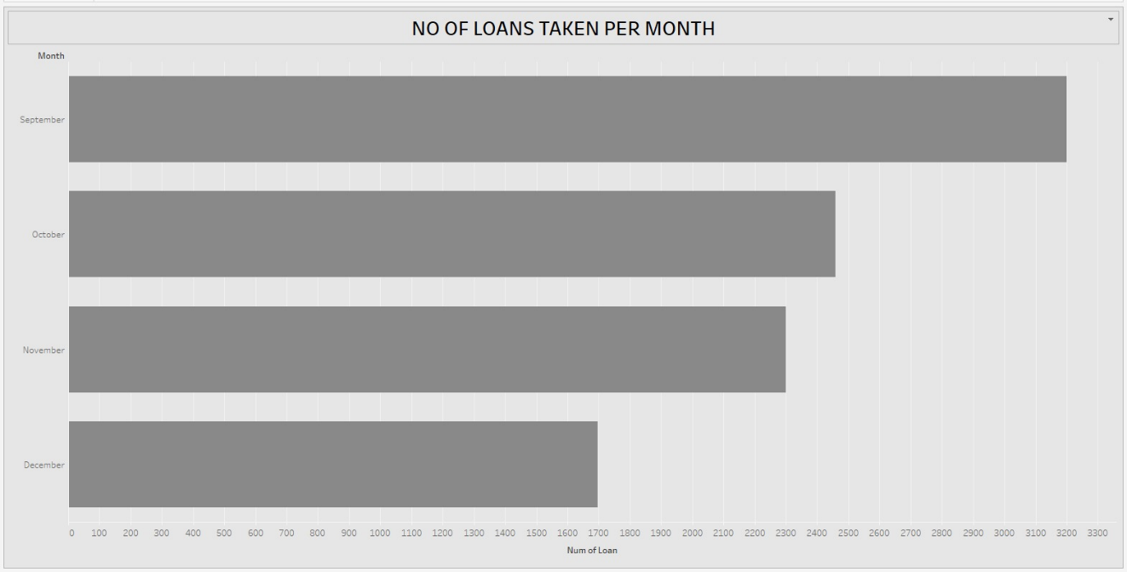

* This bar chart shows the number of loans taken from September to December.
* September recorded the highest number of loans, reaching nearly 3300.
* October saw a slight decrease, with loan numbers around 2400–2500.
* November had a similar loan count to October, slightly lower.
* December had the least number of loans, approximately 1700

**7.AMOUNT INVESTEDVS MONTHLY BALANCE**

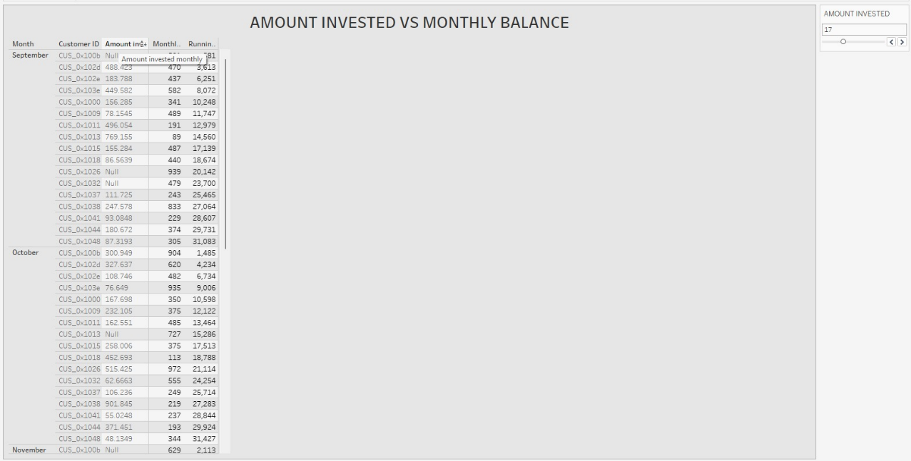

* This table visualizing customer investment data across different months (September, October, and November). Each row in the table represents an individual customer, identified by a Customer ID.
* Amount Invested: The specific amount each customer invested (some entries are marked as 'Null').
* Amount Invested Monthly: The monthly investment made by the customer.
* Monthly Balance: The resulting balance for the customer at the end of the month.
* Running Balance: A cumulative running balance across months.
* There is also an "Amount Invested" filter slider on the right side of the dashboard, allowing users to filter the table based on the investment amount.

**VISUALISATION**

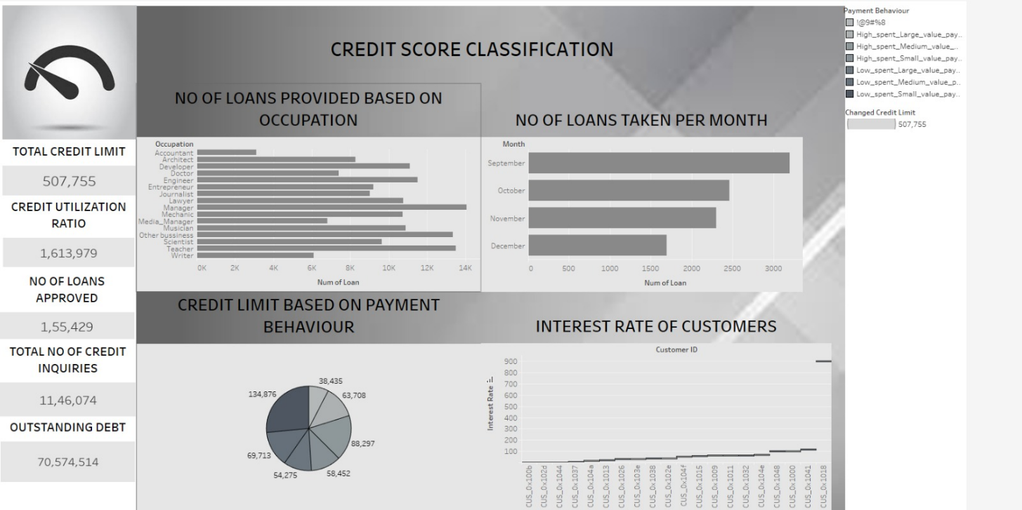

* The dashboard provides an overall view of customers' credit behaviors and lending patterns.
* Credit Overview:
* The total credit limit provided is 507,755, with a credit utilization ratio of 1,613,979 indicating a high level of credit usage compared to limits.
* A total of 1,55,429 loans have been approved, while there have been 11,46,074 credit inquiries, reflecting significant customer interest in credit products.
* The outstanding debt stands at 70,574,514, highlighting the overall financial liability across customers.
* Occupation-wise: 'Manager', 'Other Business', and 'Engineer' occupations have the highest number of loans approved, suggesting that individuals in these professions are more active in seeking loans.
* Month-wise: September saw the highest number of loans taken, indicating a seasonal peak in loan demand.
* Credit Limit vs Payment Behavior:
* Customers are segmented by payment behaviors with varying credit limits. Certain payment patterns (likely those indicating better repayment habits) have higher assigned credit limits.
* Interest Rates:
* Interest rates vary across customers, but a majority seem to cluster within a lower range, suggesting fair to good creditworthiness for most.
* Overall, the dashboard shows a healthy demand for loans among customers, but the high outstanding debt and credit utilization ratio indicate potential risks. It highlights the importance of close monitoring of repayment behaviors to manage credit risk effectively.

**CONCLUSION:**

* Total Credit Limit is ₹507,755, while the Credit Utilization Ratio is significantly higher at ₹1,613,979, indicating potential over-utilization of available credit.
* Number of Loans Approved stands at 155,429 with Outstanding Debt reaching ₹70,574,514, showing a high dependency on borrowed credit.
* The highest number of loans has been provided to Managers, followed by Engineers and other business professionals.
* Loan Applications peak around September, suggesting a seasonal trend in credit demand

.

* Credit Limits vary significantly based on payment behavior, with the highest distribution around ₹134,876 for certain customer segments.
* Interest Rates for customers are largely stable, but a few customers experience notably higher rates.

Overall, while credit access appears broad and dynamic across professions, there is a noticeable risk due to high credit utilization and outstanding debt. Stronger credit management strategies and targeted risk assessments may be necessary.